Use case:

This program allow user to manage their money and review the history according to date or/and amount money they spent or saved. The user interface looks like below:

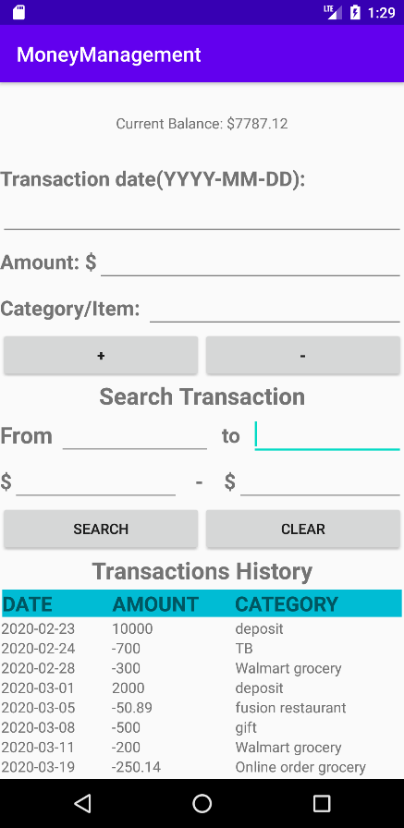

Step 1: user can enter the transaction date in order of YYYY-MM-DD, amount of money they spend and the item they bought or the category of spending.

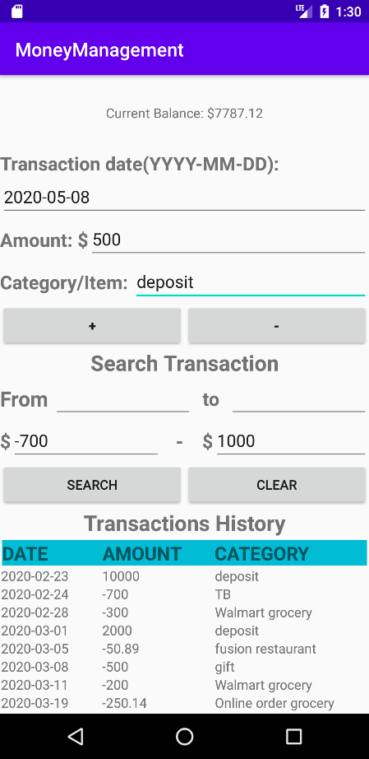

Step 2: user then can click “+” or “-” button for either saving money into their account or spending money.

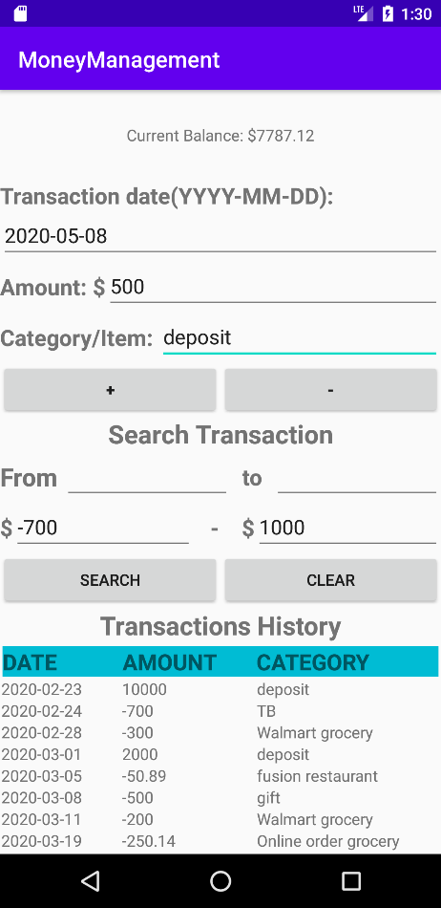

Step 3: After clicking one the button, the entry will show in the Transaction History table. User can scroll down the table to see the whole history list.

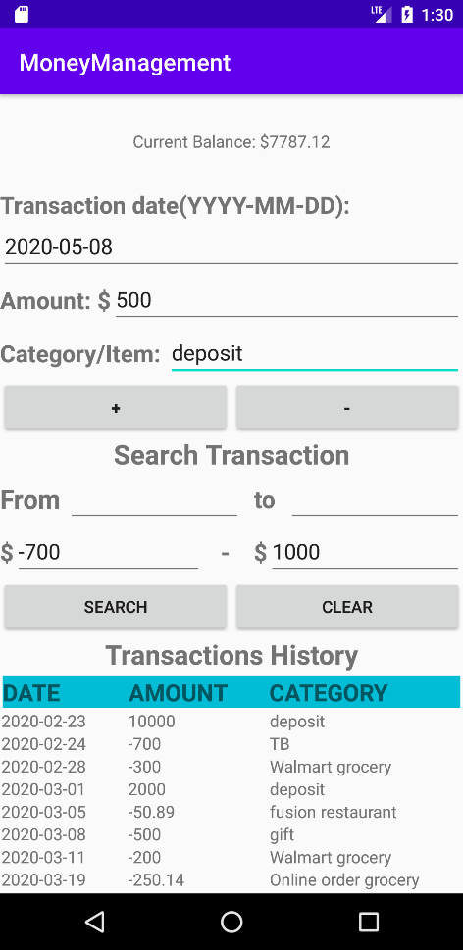

Step 4: user can also filter the transaction history table by entering the date range they want to check or/and the range of amount of money they spent or saved.

User can either enter one of the search range or any combination of them.

For example, user can check the transaction from date 2020-02-01 and the money they spent over $700, or user can check the transaction from date 2020-02-01 to 2020-04-02 and the money amount from $700 spending up to $1000 savings.

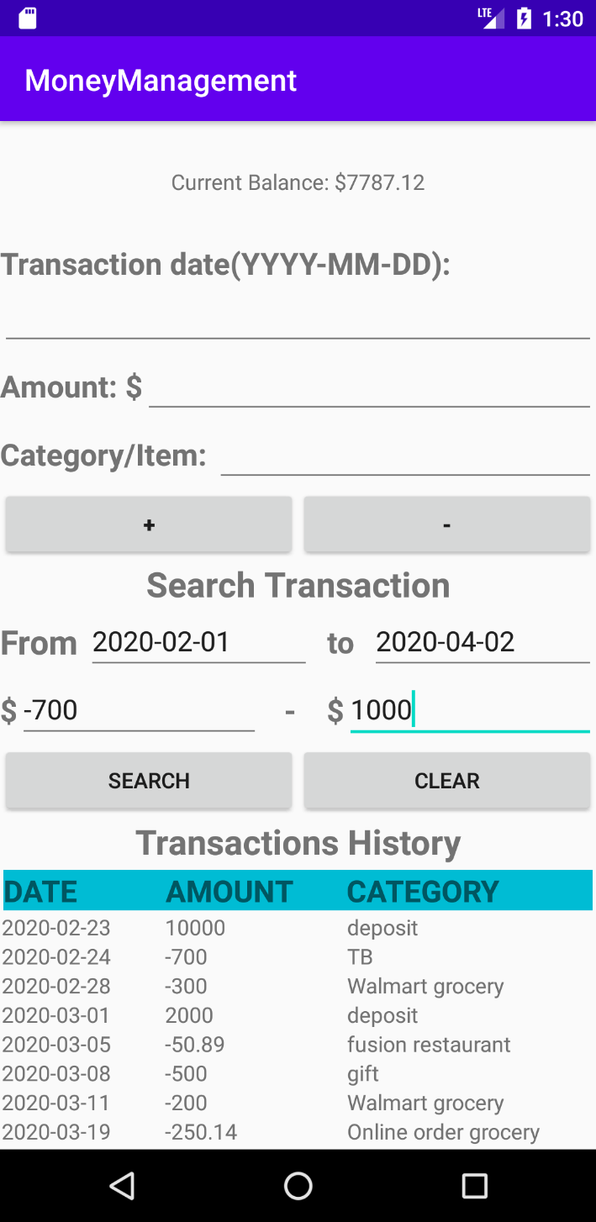

Step 5: after clicking the “SEARCH” button, the filtered data will show in the transaction table.

See below.

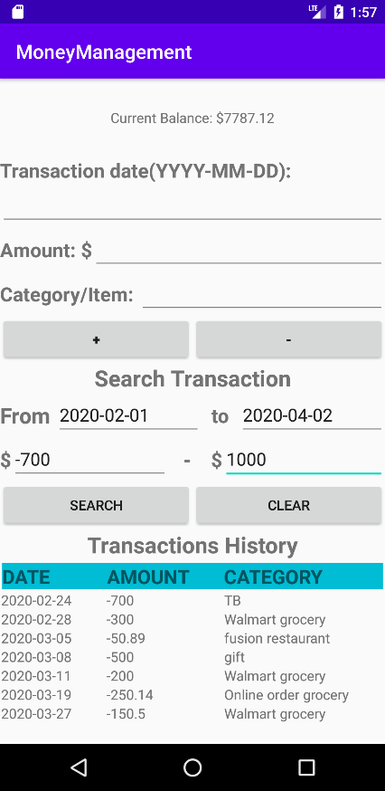

Step 6: the “CLEAR” button will help user to clear the search information and show the whole transaction history in the table.

